University of Foggia
International Relations Office 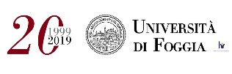

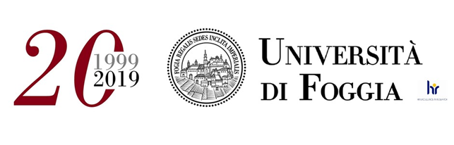

Full Legal Name of Institution | University of Foggia
Erasmus ID Code | I FOGGIA 03
Website | https://www.unifg.it/
Head of International Relations Department | Mr. Pierlugi Centola  Email: relint@unifg.it
International Relations Office address | University of Foggia  Via Gramsci 89/91  71122 FOGGIA, ITALY
 | https://www.facebook.com/UnifgInternationalDepartment/

The sending institution, following agreement with the University of Foggia, is responsible for providing support to its nominated candidates so that they can have the recommended language skills at the start of the study or teaching period:

Recommended language skills*

Receiving institution [Erasmus code]
 | Language  of instruction 1 | Language  of instruction 2 | Recommended language of instruction  level
 |  |  | Student Mobility  for Studies | Staff Mobility for  Teaching
I FOGGIA 03 | Italian | English | B1 | B2
*For more details on the language of instruction see the course catalogue.

Application Form
Nominations for students are sent to relint@unifg.it

Receiving institution [Erasmus code] | Winter term | Summer term
I FOGGIA 03 | 30th June | 15th December

Departmental Erasmus Coordinator
Department | Professor | email
Department of the Sciences of Agriculture, Food and Environment | Prof. Antonio Stasi | antonio.stasi@unifg.it
Department of Economics | Prof. Edgardo Sica | edgardo.sica@unifg.it
Department of Humanities. Literature, Cultural Heritage, Education Sciences | Prof.ssa Tiziana Ingravallo | tiziana.ingravallo@unifg.it
Department of Law | Prof. Domenico Viti | domenico.viti@unifg.it
Department Clinical and Experimental Medicine(Degree courses: Biomedical laboratory techniques, Biomolecular Sciences and Technology, Dietetics, Imaging and Radiotherapy Techniques, Physiotherapy, Sport sciences, physical exercise and human health, Dentistry and Dental Implants ) | Prof.ssa Rosa Santacroce | rosa.santacroce@unifg.it
Department Medical and Surgical Sciences  (Degree courses: Nurisng and Medicine and Surgery) | Prof. Giuseppe Stefano Netti | giuseppestefano.netti@unifg.it

Academic Calendar
The Academic Year is divided into two semesters.
Each term consists of lecture weeks.

Welcome Sessions for Erasmus+ Incoming students will take place at the beginning of each term.
Each term consists of lecture weeks.

Welcome Sessions for Erasmus+ Incoming students will take place at the beginning of each term.

For more information, please, follow the link:
https://en.unifg.it/international/erasmus-programme/incoming- students/what-can-i-study

Housing

The receiving institution will guide incoming mobile participants in finding accommodation, according to the requirements of the Erasmus Charter for Higher Education.
Information and assistance can be provided by the following persons and information sources:
Institution [Erasmus code] | Contact details (email, phone) | Website for information
I FOGGIA 03 | ESN /Erasmus Student Network/  accomodationesnasefoggia@gmail.com  Cerco Alloggio  +39 388 888 7059  foggia@cercoalloggio.com | http://www.esnfoggia.it/  https://www.cercoalloggio.com/puglia/foggia

Student Exchange information
Italian  Language Course | The International Relations Office strongly recommends Erasmus students to attend the  free Italian course the University Language Centre (CLA) offers at the beginning of  the Winter and Spring Semester.  Students interested in attending it are kindly asked to write in their Learning Agreement “Italian Language Course for Erasmus Students at CLA”.  3 ECTS.

ESN /Erasmus Student Network/
ESN FOGGIA represents the local section of the Erasmus Student Network association. It's a no profit association which, through the collaboration of volunteers, ex-students Erasmus and not, it has the aim to help the foreign students that will spend a period of study at the University of Foggia.

Contact information:
E-mail: foggia@esn.it

